P2017

Innovation Project

P5C401 Panneau LED

Final report



Nicholas Anthony

Christropher Reinartz

Xingtong Long

Encadrant du projet: MELIANI Hanane

2016/5/31

Content

Introduction 3

Work summary 4

Website 4

Teensy Logic and Programming 5

Connection Bluetooth 6

Difficulties 7

Connection Bluetooth module 7

Connection wifi module 7

Conclusion 8

Bibliography 9

Annexes 10

# Introduction

This project is based on a LED panel fabricated in laboratory LISA of CentraleSupelec, used for visualize numbers, tests, images and videos. It is controlled by software Arduino, and charged by a wooden box with 250V input and 5V output.

LEDs have many advantages over incandescent light sources including lower energy consumption, longer lifetime, improved physical robustness, smaller size, and faster switching. Light­emitting diodes are now used in applications as diverse as aviation lighting, automotive headlamps, advertising, general lighting, traffic signals, camera flashes and lighted wallpaper. As of 2015, LEDs powerful enough for room lighting remain somewhat more expensive, and require more precise current and heat management, than compact fluorescent lamp sources of comparable output.In recent years, LED display has been widely used in enterprises, schools, shopping malls, shops, public places for graphic display, advertising, information dissemination, etc., become the mainstream flat panel display products.

Arduino is a popular interactive electronic product development platform and a good basis for our project. This platform consists of hardware and software components and open sourced hardware and software. In turn, anyone can get the latest PCB design on the Arduino official website. On the software side, Arduino uses its own software development environment, uses a high­level programming language very similar to C ++, and provides a large number of library functions. This has provided us with good support, greatly simplifying application development work. In view of the many advantages of Arduino development platform, this project uses Arduino development platform to control and driver LED panel to achieve a visual display. The goal of this project is still to create a scoreboard. We plan to first create a website to input scores, words, and hopefully images. If that is successful, we will then create a mobile app which contains the same functionality. For the next update, we plan to accomplish more milestone on our way to this goal. As a group, we have learned a lot about programming with Arduino and programming with real hardware constraints. Furthermore, this project has forced to learn C++ and website development with HTML, CSS, and Javascript.

# Work summary

## Website

Current Functions of Website:

1. Ability to input score between two teams
2. A timer for regulating the time of a game

Components of website:

1. index.html, which contains
   1. links to style sheet and fonts
   2. Main HTML of the webpage
   3. Javascript to handle user inputs
   4. Javascript to regulate the timer
2. indexstyle.css, which
   1. handles positioning of elements on the page
   2. handles the style of elements on the page

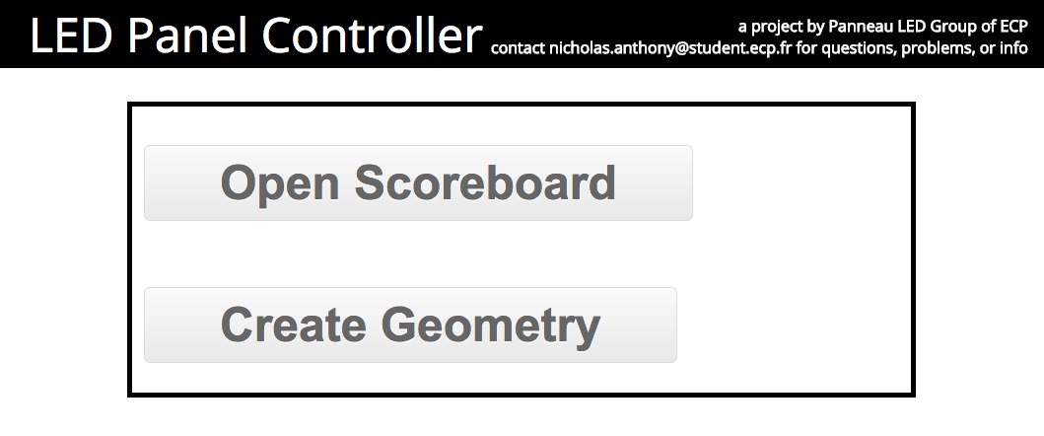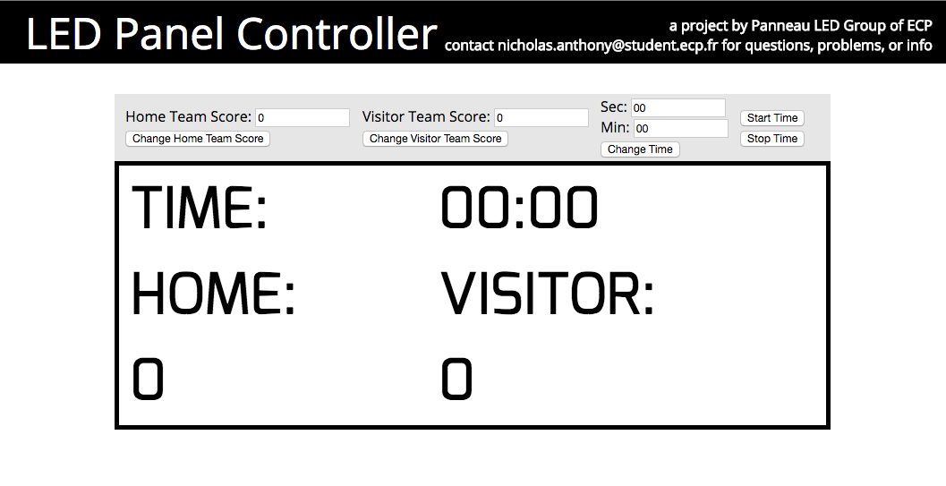

## Teensy Logic and Programming

1. UMLET Diagram of Logic

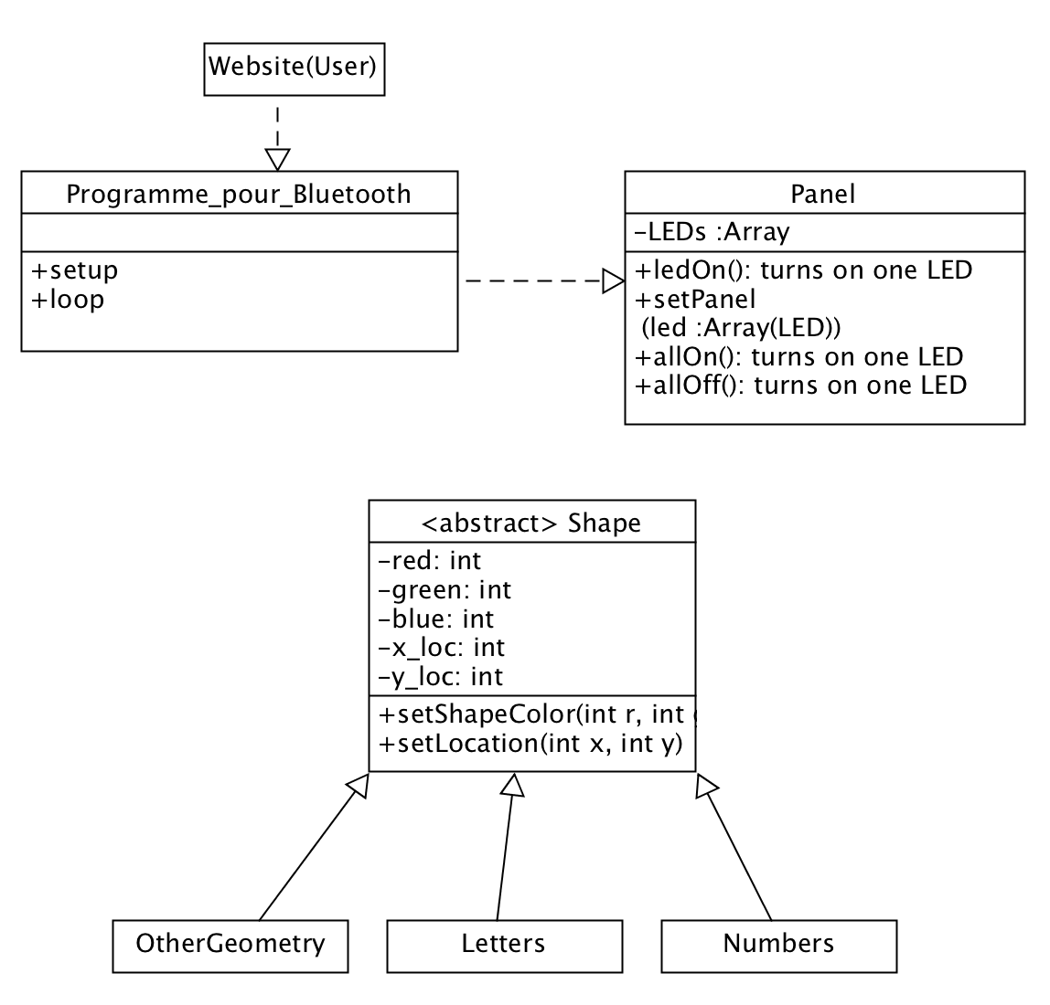

1. General Overview on how it works:

User provides input; let us assume that is a score change from 1 to 5

↓

New number (5) is transmitted to ECP server

↓

Teensy pulls new information from ECP server

↓

Main file instantiates a *Number5* instance

↓

Main file deletes (deconstructs) current *Number1* instance

↓

New *Number5* instance is given a location

↓

*Number5* instance tells *Panel* instance which LED’s to illuminate

↓

*Panel* instance illuminates corresponding LEDS

↓

Done and repeat

## Connection Bluetooth

# Difficulties

## Connection Bluetooth module

## Connection wifi module

# Conclusion

# Bibliography

# Annexes

**File 1: index.html**

**File 2: indexstyle.css**

**File 1: Programme_pour_bluetooth.ino**

**File 2: Panel.cpp**

**File 3: Shape.cpp**

**File 4: LetterA.cpp**